# DES 335

**Spring-2025**

**Week 9 Report: Encounters**

**DigiPen Institute of Technology**

## Student Name: <Matthew Oliver>

## RPG System Title: <The Court of Alphame>

## Author: <Noah Crissey>

## Report Requirements

Create **TWO (2)** **combat encounters** and **TWO (2) non-combat action encounters** utilizing the game system you are currently using for your Project 3 adventure. Using the attached doc, write up a total of FOUR (4) different and unique encounter locations, using your chosen fellow student's RPG game system as a base for mechanics and setting. Include the following:

* **READ ALOUD:** 2-3 paragraph "read-aloud" section that richly describes the location/situation to the players, written in 2nd-Person Voice (e.g.: "The room is filled with acrid smoke, making it difficult for you to see and breathe.")
* **GM INFO:** 2-3 paragraphs giving GM-oriented information that explains “what’s really going on” (i.e.: hidden enemies and their tactics, traps, environment effects, etc. Include stats and mechanics, treasure/rewards). NOTE: This is a *combat encounter*, so include one or more enemies (can be different types!).
* **ACTION ELEMENTS:** 3-4 "action elements" that the player or enemies could use to their advantage (e.g.: chandeliers used for Acrobatics checks, bottles of flammable substances used to create fire, glass-walled cubicles perfect for throwing enemies into with devastating, cinematic effect, etc.)
* **PLAYER PERSPECTIVE:** Now look at your encounter through a player’s eyes. 1-2 paragraph analysis of what you THINK THE PCs WILL DO in the encounter—not what you WANT them to do, but what possible tactics, spells, maneuvers, tricks, etc. Do you have contingencies to handle these?
* **MAP:** Include a tactical map (with grids to indicate distance) that gives an overall layout of the encounter. This is a “GM MAP” with all the annotation and information that would be inside an adventure.

## NOTE: Integrate, Don’t Cut and Paste

You can utilize this information into your P3 working document. DO NOT merely cut-and-paste what you write into your draft and be done with it—it will still require editing, massaging, and formatting to integrate.

## Rubric

This, like other weekly reports, is not considered a separate grade, but affects your overall final grade.

* **-2%:** Not Submitted at time of grading
* **-1%:** Insufficient information and/or overly cliché, uninteresting, or boring; Late turnover of assignment (Instructor discretion)
* **+0%:** Sufficient information, description, originality, and variety
* **+1%:** Very interesting and engaging encounters with excellent description

This page does not count towards total page count; start on next page.

# Combat Scene/Encounter #1

# <Inquire>

**READ ALOUD TEXT**

*The sun is bright in your eyes and every smell imaginable assaults your nose. You can barely hear over the cacophony of noises beating against your head. Just moving is difficult as it seems like every step you take results in you being knocked around by some passerby.*

*You are in by far the busiest district in Alphame, the Docks. Thousands of people bustle about, each carrying out a task that they seem to believe is life and death. You can see merchants barking orders, sailors struggling to carry massive crates of goods, and guards strutting around.*

*Your efforts to acquire a fleet of merchant ships has led you to the Docks, where a local shipwright and dealer of information conducts his business. Your sources have told you that his shop lies somewhere along the coast, and you’ve come to far to stop now.*

*And that is how you’ve ended up here, standing in front of an unimpressive, run-down building with a busted up sign that reads “I make boats.”*

**GM INFO**

Nobody knows the Shipwright’s name; he’s just the Shipwright. He makes many of the small fishing boats that can be found patrolling the waters of Lake Bayvah. He is also the most well-known and best-informed dealer of information in the Docks.

Not much is known about the Shipwright, where he comes from, how he gets his information, but one thing is common knowledge. The Shipwright hates the shipping industry. He thinks it should be massively scaled back so that the fishing industry can come back. He’ll tell this to anyone who will listen, so even if you choose not to have your players start with that knowledge he will share it. This is a Detail with an importance of 2, if the players choose to use this and agree with the Shipwright he will use the Probe Action to determine if they’re telling the truth.

The Shipwright is able to tell the players the name of a merchant who is down on his luck at the amount and could potentially be convinced to get out of the game. His name is Geoffery, and lately his luck has taken a turn for the worse. Geoffery has a little known gambling problem and has recently lost much of his fortune. This is a Secret with an Importance of 3, Geoffery does not want anyone to know about this, especially his wife.

The Shipwright is willing to tell the players about Geoffery but is reluctant to do so. He and Geoffery used to be friends back in the day before they grew apart, and the Shipwright still wants to honor that friendship. The Shipwright is especially unlikely to tell the players about Geoffery’s secret, it will require a lot of coercing to get that information out of him.

At the end of the day however, this is the Shipwright’s job, and though it might take a lot, enough money might get through to him. The Shipwright is always willing to part with information for enough money, the players would not know this but it could potentially be revealed during the Social Encounter. This is a Detail with an Importance of 1.

**ACTION ELEMENTS**

* Geoffery’s Secret
* Both of the Shipwright’s Details

**PLAYER PERSPECTIVE**

It is likely that the players will attempt to use the Shipwright’s first Detail, which could go either very well or very poorly. If it goes well the players will likely breeze through the rest of the conversation and learn about Geoffery fairly easily, but might not dive deep enough to find out about his secret. If they fail they might have to claw their way back, and in the process discover not only that a secret exists, but that the Shipwright is willing to part with it for the right price.

The Shipwright:

Rank 2

Medium

Patience 5

Guile: 0

Insight: 1

Stability: 3

Flatter: d10

Intimidate: d10

Persuade: d6

Deceive: d6

Assure: d8

Mediate: d8

Stonewall: d10

Strongarm: d10

Prod: d4

Observe: d6

Recall: d6

Question: d8

**MAP**

**Shipwright located on stool behind counter**

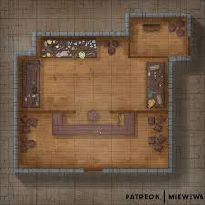

<https://i.pinimg.com/736x/55/c5/54/55c5544dfe89a73ede1159fdbb29fd34.jpg>

# Combat Scene/Encounter #2

# <Locate – The Stormtrader’s Guild>

**READ ALOUD TEXT**

*After learning about the merchant Geoffery you chose to make your way to the Stormtrader’s Guild. It feels like home, clerks mill about, managers berate employees for getting their calculations wrong, and merchants swagger about, many with overfully full coin purses. The ceiling is domed and sits far above you, making the building look like one of the cathedrals they have in Thaelex.*

*Before you stands the man you’ve come to see. “Diggory Brooksmore, at your service.” The man bows at the waste, flourishing his hand in front of him like he’s convinced that the High Magistrate himself stands before him. He is a wiry, weasel-like man. Tall and thin, his fingers look like they were made for counting money. His shrill voice pierces at your ears, his tone dripping with unashamed greed. He looks at you like a predator eyeing his next meal, probably wondering how much money he can squeeze out of you before you leave.*

*“Follow me please.” He leads you down a hallway and into an office, where a sparsely decorated desk sits in the center. The room is well lit, and the light dances off the golden scale that sits front and center on his desk. He has a bookshelf in the corner that looks to hold folders, probably full of financial records. Other than that there is almost nothing in the room, no chairs for guests, no tables, no decorations. This room has one function and one function only, to make money.*

*Diggory sits down behind his desk and smiles up at you all, “Now. How may I help you?”*

**GM INFO**

The players have made their way to Diggory Brooksmore in order to find out Geoffery’s current whereabouts, a daunting task in a city as large as Suncrest. Diggory does know where Geoffery currently is and is more than happy to tell the players, for the right price.

The main difficulty of negotiating with Diggory is that he is insulted when the players attempt to negotiate down his price. He will start by asking for 30 Wealth, an obviously ridiculous sum, and every time the players make a lower offer he scoffs at it and makes a show of resisting. He can eventually be brought down to just 2 Wealth, but it is an arduous process to get him there.

If at any point the players mention anything relating to the concept of being poor Diggory will freak out and start rapidly backpedaling. Saying things like “Who’s poor, nobody is poor!” This is because Diggory has a Secret with an Importance of 3, he used to be a street urchin. Diggory has worked his way up to this point from nothing, which most people would either applaud or just not care about, but Diggory thinks that it is the most shameful thing on the planet. The players can use this Secret by simply choosing to press the poor issue, even without saying Diggory’s Secret directly.

A Detail about Diggory is that he is extremely cowardly, being especially vulnerable to threats. Upon being threatened by the players his Detail (Importance 2) is activated.

**ACTION ELEMENTS**

* Diggory’s Secret
* Diggory’s Detail

**PLAYER PERSPECTIVE**

I imagine the player’s initial response is going to be to act outraged at the price being asked and bring it way down. They might then backpedal and end up either paying too much, or mentioning the concept of poorness in regards to the hefty sum. If they choose to continue to press for a lower price they might end up choosing to intimidate Diggory, which will also allow them to get a bonus.

Diggory:

Rank 2

Hard

Patience 7

Guile: 4

Insight: 1

Stability: -2

Flatter: d10

Intimidate: d4

Persuade: d8

Deceive: d8

Assure: d8

Mediate: d8

Stonewall: d6

Strongarm: d6

Prod: d4

Observe: d6

Recall: d6

Question: d6

**MAP**

**Diggory located in his chair behind desk**

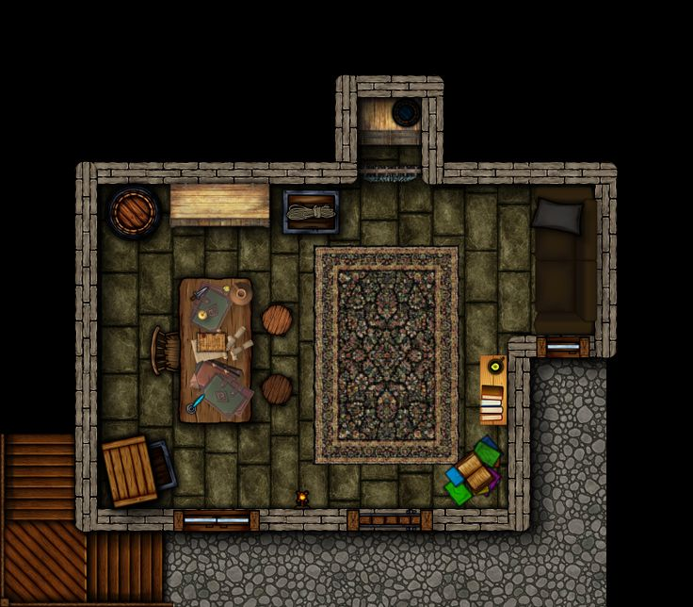

https://i.pinimg.com/736x/d8/1f/d5/d81fd543e0e2dc41a99e9795be34c6a0.jpg

# Non-Combat Action Scene/Encounter #1

# <Mrs. Callahan>

**READ ALOUD TEXT**

*Here it is, the home of Geoffery Callahan. It’s a modest little mansion located in the West Side of the city. A long drive, lined by short trees, leads up to the front entrance. The mansion itself it a bright but pleasant white with three stories and plenty of windows. As you make you way to the entrance you see that the lawn is finely kept but starting to get a little long.*

*As you reach the front doors they open to reveal a short woman in an expensive looking dress. “Hello, may I help you? I’m so sorry but my husband has given all the help a vacation, I’m Mrs. Callahan.”*

**GM INFO**

Mrs. Callahan is very devoted to her husband and is more than happy to talk about all the wonderful things that he buys for her. She does not offer to let the players inside and instead gestures at what can be assumed to be the objects she’s describing. She claims that she doesn’t know where her husband is at the moment, the last time she saw him he told her he was giving the staff a well-deserved vacation. She is very proud of this fact and if the players agree that it was very nice of her husband to do so it counts as a Detail with an Importance of 1.

When she claims not to have any idea where he is the players might notice that she’s slightly uncomfortable. This is because she is lying, Mrs. Callahan does actually know about her husband’s gambling and she knows that when he has a particularly bad streak he usually ends up at a bar on the East Side called “The Gilded Mug.” She doesn’t want to tell the players this however because not even she is supposed to know it.

She can be convinced that she should tell the players however, especially if they make it sound like they want to help him. A Detail about Mrs. Callahan is that she truly believes in her husband’s mercantile abilities, this has an importance of 3. If the players mention that they want to buy his ships she will be very happy because she believes that he can use the money to get back on his feet.

**ACTION ELEMENTS**

* Detail in read-aloud about the grass looking slightly tall put together with Mrs. Callahan saying that the staff is on vacation could allow the players to realize that he’s lost his fortune if they don’t know already
* Both Details about Mrs. Callahan

**PLAYER PERSPECTIVE**

It is very likely that the players will tell Mrs. Callahan about their intention to buy Geoffery’s ships. This will give them a head start on getting the information from her. From there they just have to push her to tell the truth and they should be able to get the information. If the conversation somehow goes awry there should be other opportunities and details that will let them bring it back.

Mrs. Callahan:

Rank 1

Easy

Patience 10

Guile: 0

Insight: 3

Stability: 2

Flatter: d4

Intimidate: d10

Persuade: d6

Deceive: d6

Assure: d6

Mediate: d8

Stonewall: d10

Strongarm: d10

Prod: d10

Observe: d4

Recall: d6

Question: d8

**MAP**

**Mrs. Callahan located at front entrance**

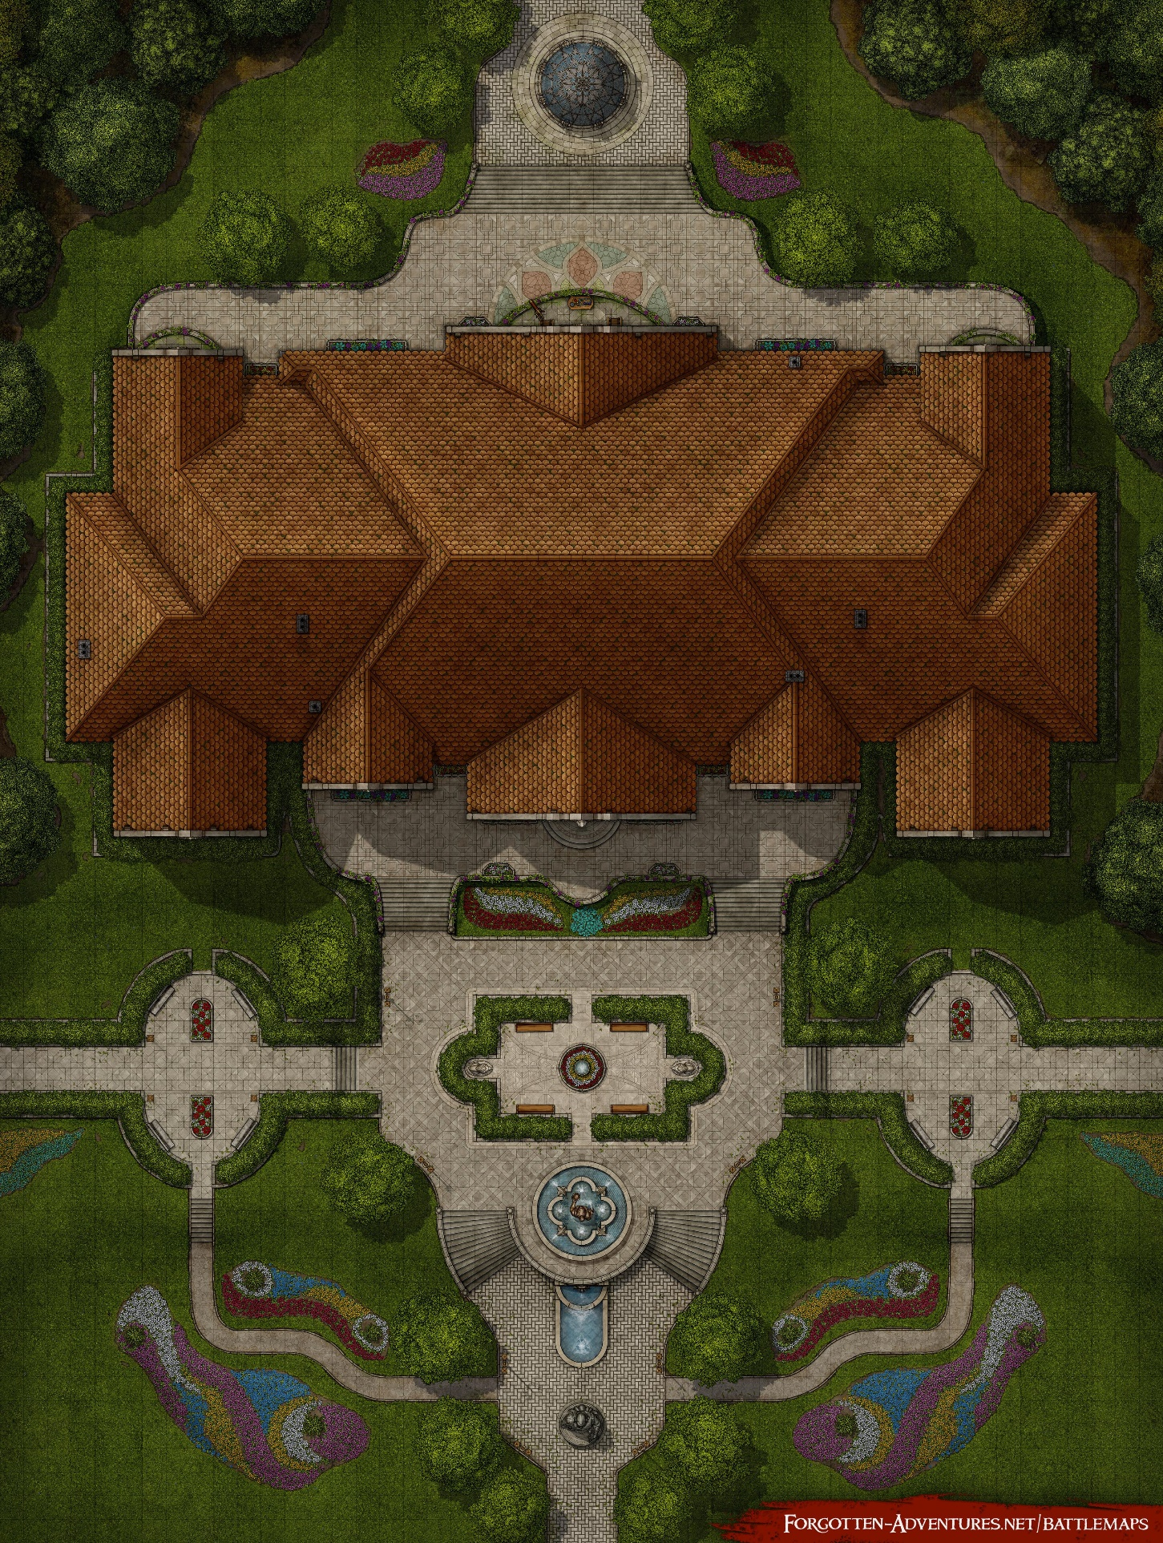

<https://i.redd.it/the-manor-house-49x65-v0-i76jnm3xu8pb1.jpg?width=3430&format=pjpg&auto=webp&s=c081e536654324091cbb176032afe010a489ccb7>

# Non-Combat Action Scene/Encounter #2

# <Geoffery Callahan>

**READ ALOUD TEXT**

*You find yourselves standing in the middle of a grimy, dirt street. People in filthy, tattered clothes pass by, hungrily glancing at your fancy garbs and jewelry. It smells of filth, and even as you think that you see someone dump a bucket of something out of their window, you don’t even want to guess its contents.*

*Before you stands “The Gilded Mug,” only the sign reads “T G ded ug.” The place is so filthy and run down that you’re amazed it’s even still standing. You see spots where windows used to be, but they’ve long since been boarded up.*

*You step inside and it’s just as terrible as you imagined. Every surface is dirty, there are more tables and chairs missing legs than there are that have all of them. And at the bar sits a dingy man who looks like he hasn’t washed in a week. Unfortunately, that man matches the description you have of Geoffery Callahan.*

**GM INFO**

Geoffery is wallowing in grief. He’s really screwed up this time, everything is gone. The only things he has left are the mansion and the ships, and he won’t be able to keep those for long. Geoffery is an angry drunk, and will treat the players poorly. Upon hearing the player’s intention to buy his ships he will respond with disdain. He will liken the players to vultures come to pick at a rotting corpse. This is a difficult encounter, and must be played carefully.

There are two details that can help the players. The first is that Geoffery is fond of nice clothes, he will likely make a comment about the nice garb the players are wearing, maybe mentioning a specific brand or store. Geoffery’s love of clothes is a Detail with an Importance of 1, usable if the players mention him being able to dress nicely again. The second Detail is that Geoffery is very fond of what he calls his “Flagship,” a rather nice vessel called “The Flowing Breeze.” This Detail has an Importance of 2. If the players somehow work into the deal that he can keep his flagship, he will respond positively.

The players can also use Geoffery’s secret if they’ve learned it at this point. That he’s a gambling addict who has lost his entire fortune. This Secret has an Importance of 3.

**ACTION ELEMENTS**

* Both Geoffery’s Details
* Geoffery’s Secret

**PLAYER PERSPECTIVE**

It is likely that the players will discover both of Geoffery’s Details, and will end up using them. They will realize quickly, however, that they need to play Geoffery carefully, his drunken state makes him very difficult to work with. The players should realize that this encounter will require slow advancement, making sure to constantly manage Geoffery’s Patience.

Geoffery:

Rank 3

Very Hard

Patience 3

Guile: 2

Insight: 4

Stability: -2

Flatter: d10

Intimidate: d10

Persuade: d6

Deceive: d8

Assure: d8

Mediate: d8

Stonewall: d10

Strongarm: d10

Prod: d8

Observe: d6

Recall: d6

Question: d8

**MAP**

**Geoffery is located in the left-most bar stool**

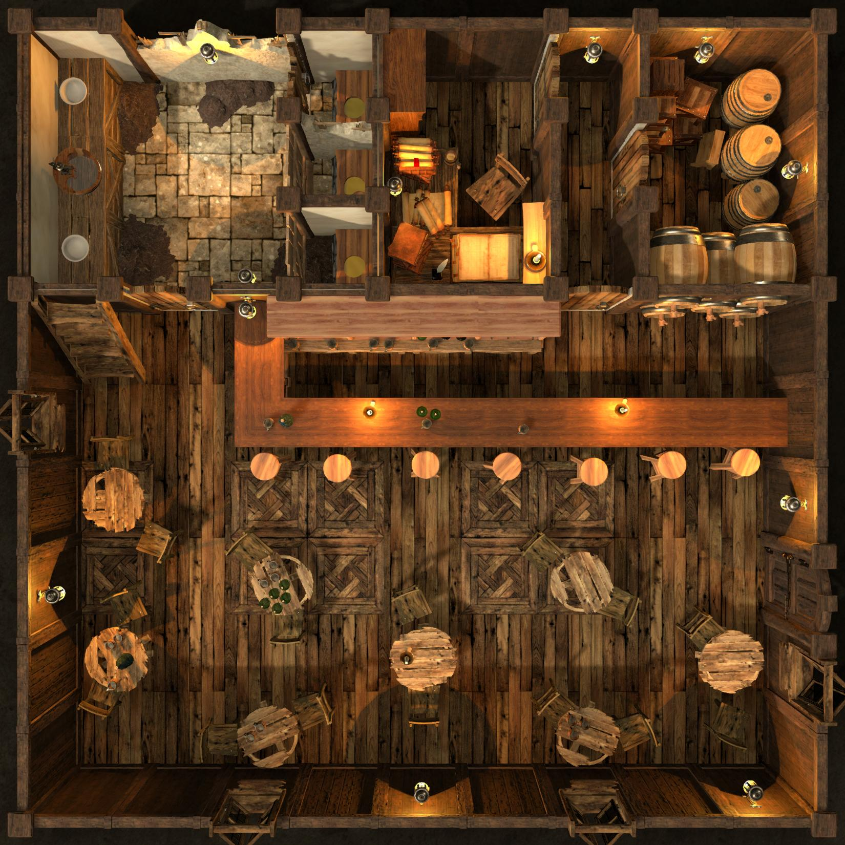

<https://i.redd.it/aut47ldkdgkd1.jpeg>